# Letter of Transmittal:

Himesh Buch

57 Lipman Dr,

New Brunswick, NJ 08854

September 20, 2020

Dave Howland

Rutgers Writing Program

Murray Hall Room 108

510 George Street

New Brunswick, NJ 08901

Dear Professor Howland,

I would like to start off this letter by saying how much fun I had putting this project together. This project gave a chance to my friends, family, and myself to do a fun activity, which is Karate in this case. I did Karate growing up and chose the topic of demonstrating Kata for the project because I believe that it can really help people to protect themselves from any kind of attacks, as Karate or any other form of Martial Arts is designed for self-protection. Kata, an integral part of karate, is a combination of punches and kicks to form a pattern that can help in protecting from different attacks.

You will find a design plan memo that contains information like audience and purpose, setting and hazards, performance objective, and tentative design plan, attached to this project. Anyone who is interested in learning Karate or have done it in past qualifies to follow and educate themselves about this topic. As mentioned earlier, the purpose of this project is to help people with self-defense and should not be used to initiate any kind of violence. Katas have different levels of difficulties, and the Kata that is mentioned here in this project is a basic-intermediate level, and thus, it should not be very difficult to follow.

A google drive link will be sent along with the submission of this entire document (https://drive.google.com/drive/folders/121LCe8gdmwV8qgmdjyawSX28heP6xIz-?usp=sharing). That link will contain all the videos that are important for this demonstration. I thank you for guiding me throughout the making of this, and I genuinely appreciate your efforts.

Sincerely,

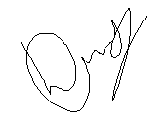

Himesh Buch

# Design Plan Memo:

To: Professor Dave Howland

From: Himesh Buch

Subject: Design Plan Memo for performing a Kata

Date: October 30, 2020

This memo serves to outline my plans to create a set of instructions for performing Kata, which is basically a combination of punches and kicks, and also to learn a bit more about Karate. It includes a brief discussion of the audience and purpose of the instructions, the setting and potential hazards, and a timetable for developing, testing, and producing the instructions.

**Audience and Purpose**

Anyone who has done some Karate or have no idea what karate is, this document will help them learn a bit about Karate and Kata. It is very important for whoever is performing to make sure to not misuse the strategies and techniques for their advantage or to initiate any kind of violence. Not only that, Karate or any other form of Marital Arts is only for self-defense and should not be used for anything other than that.

**Settings and Hazards**

Karate is something that requires one to move around in the area where it is being performed. It is very important for the performer to be able to freely move around in a room or any other open space. Not only that, throwing different punches and kicks can harm their body (i.e. dislocation of different body parts). It is highly advisable to perform the below steps under strong supervision as it is easy to get hurt.

**Performance Objectives**

I would like the user of these instructions to be able to learn things like basic stance, different punches and kicks, intensity, and right techniques, but most importantly the purpose or the reason to learn it, which is only self-defense. Below is a list of some qualities/performance criteria I would like the instructions to meet. The instructions should be:

Illustrated with clear, intuitive photos or videos

Easy-to-follow

Engaging

Contextual

**Tentative Design Plan**

I would like to make a multi-page document for this project. This will allow me to easily put everything together and share it easily with everyone online. It will include photos, videos, and step-by-step instructions. The instructions will be divided into the following sections:

* Name of the Kata: as there are numerous katas available, the name for the one that is picked for this project is mentioned
* Step-by-step instructions: contains proper techniques and guidance to help achieve the most out of it
* Usability Testing: questions asked for usability testing along with graphical representation of the results

**Document revision:**

After sending it out to friends and family, I realized that they preferred videos over static photos. I had to redo some of the things, in order for them to completely understand all the steps. One of the main things I made sure of is the clarity and easiness and peer review and revision helped me achieve that. The usability testing results attached with the document is after revision.

**Production Schedule**

I will develop and test these instructions with the help of friends and family over the next few weeks. Here are a few important dates and deadlines to help keep the project on track.

*October 7*: Be ready with rafts and a copy of your design plan memo for the instructions. Discuss it with classmates and professor and make sure professor approves the topic of choosing

*October 20 or 21*: Test instructions by having friends try cooking the meal following my rough draft instructions. Prepare two-minute talk for class the coming week.

*October 26 or 28:* In class, deliver a 2-minute “elevator speech” on my emerging instructions project. Receive and provide feedback on other’s projects.

*November 2*: Upload my final project (instructions, letter and design plan memo) in one file by class time to Sakai. Hand in physical set of instructions to professor at start of class.

# Elevator Presentation:

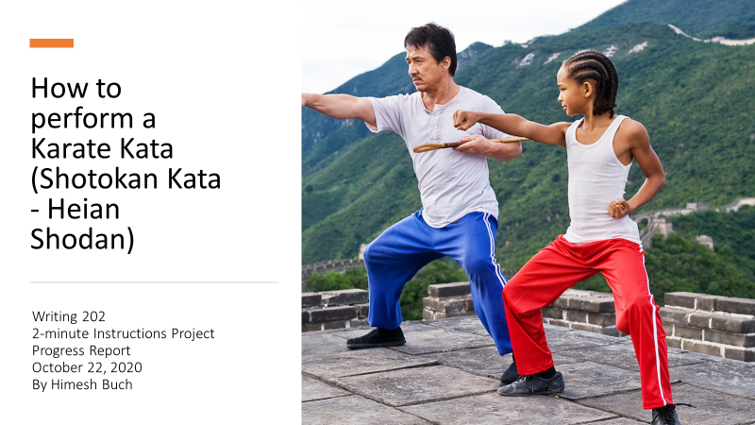

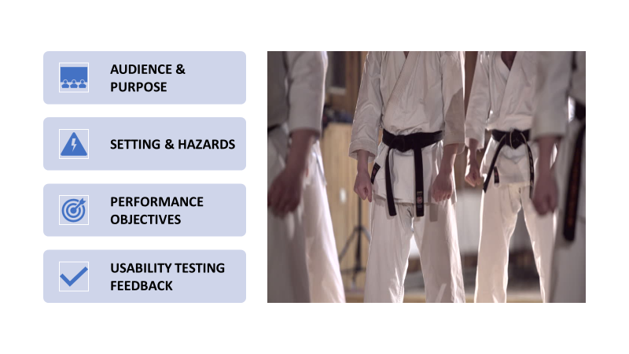

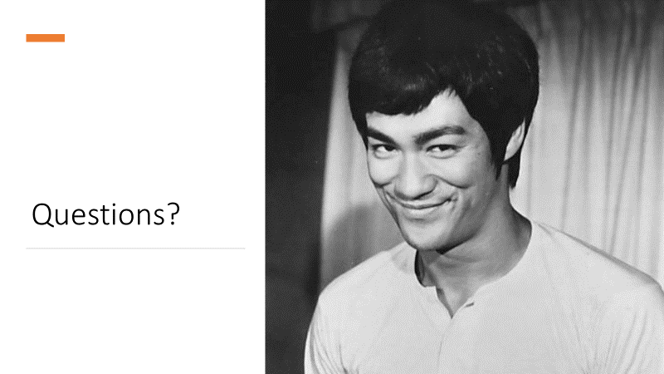

# Instructions:

**Kata name**: Shotokan Kata - Heian Shodan

**Steps**:

1. Start off with the natural initial stance

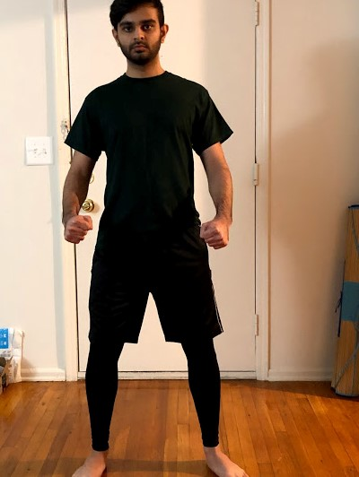

1. Start with the normal stance and follow the Left-Right-Center movement. Following that combination, initiate with a left side low block. Going to the left side means that the left hand comes up high and only the left foot moves. This is how the low block works. Look at the opponent in the eye and keep your stance still. Please take a look at video 1 to see a demonstration of this.
2. Step forward and do a stepping punch in that direction. Please take a look at video 2 to see a demonstration of this.
3. Go around to right by bringing the right hand high and left hand low, by looking over your right shoulder all the way around. Your right foot should move and do a block. Once in the position, do a hammer fist. Please take a look at video 3 to see a demonstration of this.
4. Step forward in the same direction and throw a punch again in the original stance. Please take a look at video 4 to see a demonstration of this.
5. Look towards the center of the room, bring left hand high, right hand low, step, and block. Please take a look at video 5 to see a demonstration of this.
6. Do three rising blocks in the center forward direction. This is the end of the first half. Please take a look at video 6 to see a demonstration of this.
7. Bring left hand high, turn all the way around and throw a step forward punch. Please take a look at step 3 or video 2 to see a demonstration of this.
8. Now, just like the first position, bring right hand high, left hand low, and look around to the right by moving your right foot, do a block, and punch in that direction. Following the Left-Right-Center combination, now in order to turn to the center direction, keep left hand high, right hand low and move your left leg and block. Please take a look at video 8 to see a demonstration of this.
9. Now instead of high blocks, this time do punches in the backward direction. Make sure that the punches are to the stomach level. Please take a look at video 7 to see a demonstration of this.
10. To close up the kata, we are going to do four knife hand blocks. These are the parts that most people have issues with as they are difficult to perform. We are going to do a big turn, just like before, but instead of throwing punches, this time do knife hand block. Left hand comes up high, right foot comes all the way around and then do knife hand block. After this you might end up at an angel, ideally it should be about 45 degrees. Please take a look at video 9 to see a demonstration of this.
11. This step is just a variation of the above step. Change the stance to properly point at the 45 degrees angle, bring right hand up, being the back knee in over at that angle and do a knife hand block. This is the end of our Kata.
12. Look towards the front and come back to the original position. Be aware and hold the stance. It is the same stance as the one mentioned in the first step

## Usability Testing:

The survey asking these questions (results are on a scale of 0 to 10) was sent to some friends and family:

1. How difficult it is, 0 being the easiest and 10 being extremely difficult?
2. How clear the instructions are, 0 being not so clear and 10 being very clear?
3. How likely it is to recommend to someone, 0 being not very likely to recommend and 10 being very likely to recommend?

Here is a graphical representation of the responses: